Science 9 | Unit A
Lesson 7: DNA and Heritable | 84 mins

We have looked in the past at inheritable traits, but we have yet to talk about how those traits are passed down.

There is two ways:
- DNA (Genetic)
- Environment (Taught)

DNA
- Genetic material found in the nuclei of cells  - Double Helix (Ladder twisted)  Uses  - Criminology  - Taxonomy (Classifying organisms)  - Archeology  DNA Picture: How they saw a double helix in this picture is anyone’s guess…  DNA Structure  DRAW Again  DNA Forms  Chromosome: Tightly compact DNA stands  Gene: an uninterrupted segment of DNA, containing the coded instructions for life  Chromosomes  - Humans have 46 (23 pairs)  - Dogs have 78 (39 pairs)  - Cats have 38 (19 pairs)  - Fruit Flies have 8 (4 pairs)  Code for Life:  - Genes are located on the chromosomes  - Each chromosome contains numerous gene locations  - Like chromosomes, genes come in pairs  - Both genes in a pair carry DNA instructions for the same thing  - The DNA code may not be exactly the same in both locations  Alleles: The possible forms of a gene on a chromosome. | - Deoxyribonucleic Acid  - DRAW  Found by:  James Watson and Francis Crick.. and Rosalind Franklin (x-ray tech)  A = Adenine T = Thiamine  C = Cytosine G = Guanine  Our bodies can replicate these molecules but some we have to eat proper proteins to get them  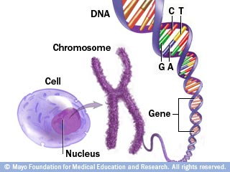  Chromosomes are always paired!  From fruit fly research  Dominate Alleles: that trait will show when paired with recessive or dominate alleles  Recessive Alleles: that trait will ONLY show when paired with other recessive alleles

Cell Division

WATCH YOUTUBE MOVIE (https://www.youtube.com/watch?v=Ba9LXKH2ztU)

Mitosis – The exact copying of a cell and DNA for reproduction of a cell  Meiosis – The making of cells that have half the amount of chromosomes needed for a whole organism. | Examples: Somatic (body) cells for repairing damaged cells, Asexual reproduction  Examples: Sex cells (gametes) used for reproductions during sexual reproduction.

Practice: Pg. 45 #1,3,4,10
Pg. 48 #1,2,3,7

