Science 9 | Unit C
Section 3.1

Transport of Materials Through Air, Soil, and Water
TRANSPORT IN AIR  Three stages of transport:  1. Release  2. Dispersion  3. Deposition  Transport in Water  Substances that are dissolvable in water can travel long distances  GROUNDWATER  Ground Water – Soil that is completely full of water  Water Table – top of the ground water zone  Permeable – soil that water can easily enter  Pores – the spaces between soil particles  Leachate – the liquid that passes through soil  Surface Water  Lakes, Rivers and Oceans  - can cover great distances  Transport in Soil  Depending on the permeability of the soil, water that lands on soil can do any of the following:  - Evaporate  - soak into the soil and is taken up by plants  - run onto the street or into a stream  - soak through the soil and moves downward.  Transport of Hydrocarbons  - Water dissolvable  - Non-dissolvable | 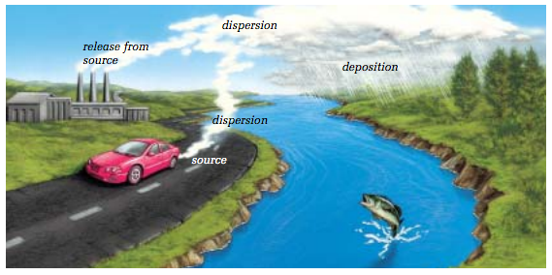  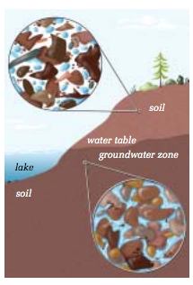  DRAW  Depending on the type of soil and what is found in the soil  Oil-based substances  Can travel LONG distances in the water  Coat the soil particles and is VERY hard to clean

Pg. 242 Questions 5-7

