Science 9 | Unit A
Lesson 6: Asexual vs. Sexual Reproduction | 84 mins

Prelesson:

Characteristics are passed from one generation to another and although the offspring “look” similar to their parents, they display different physical and behavioural characteristics.

In this section we are going to focus on the way characteristics are passed through sexual and asexual reproduction.

We will include the role of DNA, genes and chromosomes in carrying the characteristics from parents to offspring.

Introduction:

Dandelions produce dandelion seeds during reproduction. Can you imagine the seeds becoming a spruce tree, poplars, or mushrooms?

Asexual vs. Sexual Reproduction
One Species’ baby will grow up to be like their parents.  Reproductive Strategies: Methods used by an organism to reproduce  Asexual Reproduction  Binary fission: the Splitting of a single-celled organism into two new organisms which are approximately equal in size.  Budding: a smaller version of the organism grows out of the adult and when ready, becomes it’s own organism.  Sexual Reproduction  Gametes: a cell that has only one role… to find another gamete to join with during reproduction.  Animal Reproduction Cells and Process:  Fertilization: the combining of the male and female gametes making a zygote. (Two halves make a whole.)  The zygote undergoes cleavage, replicating until this multicellular life form is known as a embryo.  Plant Reproduction Cells and Process  Pollination: When pollen combines with the ovules of the plant.  The zygote grows into an embryo inside a seed. That seed protects the embryo until the conditions are right for growth of a new plant.  Draw the Parts of a Flower  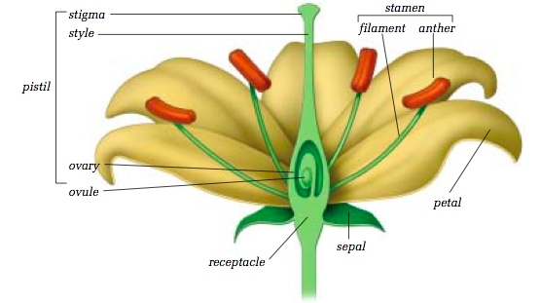  Sexual  Adv.  LOTS of variation  Dis.  Lots of energy needed  Limited offspring  Organisms that Reproduce both Sexually and Asexually  Fungi/Aphids/Earthworms | Amoebas form new amoeba through binary fission.  Very few animal species can reproduce asexually. He Hammerhead Shark has been known to go through parthenogenesis, virgin birth.  My Mexican Hat Plant  Sex Cells, Sperm, Ova, Pollen  Sperm Cell: the male gamete in animal sexual reproduction. (Half the genetic material)  Egg Cell (Ova): the Female gamete in animal sexual reproduction. (Half the genetic material)  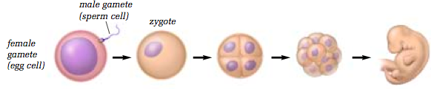  Pollen: male gamete of a plant, found on the Stamen, or ‘male’ part of the plant.  Ovules: Contain the female gametes of the plant. Found in the pistil  Asexual  Adv.  No Specialized Cells  Very Quick  Dis.  Very little variation

