Science 9 | Unit B
Section 1.2 - 1.3 | 84 mins

Unit B - Matter and Chemical Change
Unit Focus Questions  - How do we determine the properties pf a variety of different substances?  - How do different substances interact?  - What evidence can be used to indicate that an interaction between substances has occurred?  Foam in a Cup Demo  - Corn syrup | Tell them to leave space so that they can answer these questions at the end of the unit.  Pg. 91

Section 1.2 – Organizing Matter
Learning Outcomes  - Investigate and describe properties of materials  - Describe and apply different ways of classifying materials based on their composition and properties  States of Matter  - Solid  - Liquid  - Gas  - Plasma  Changing States  - Between Solid and Liquid  Melting  Freezing  - Between Liquid and Gas  Evaporation  Condensation  - Between Solid and Gas  Deposition  Sublimation  - Between Gas and Plasma  Ionization  Recombination  Physical Properties Activity  Physical Properties  What you can see, smell, feel  Physical Change  The substance does not change composition  Chemical Properties  What happens when the substance reacts  Chemical Change  New Substances are formed  Investigating Physical/Chemical Change | Chemical vs. Physical Properties  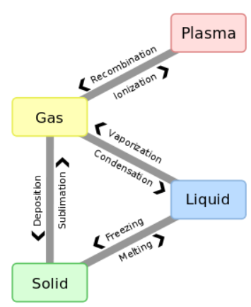  Find a simple lab for class  Melting Point, Boiling Point, Hardness, Malleability, Ductility, Crystal Shape, Solubility, Density, Conductivity  Reaction with acids, Does it burn, react with water, reaction to heat  Evidence of Chemical Change  Change in Colour  Change in Smell  Formation of a solid or gas  Release/Absorption of Heat Energy  DEMO: PG. 106

Pure Substances vs. Mixtures
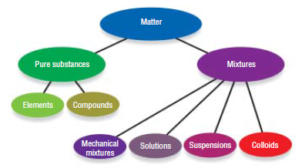
Pure Substance – Made of only ONE kind of matter  Element – Something that can’t be broken down into a simpler substance  Compound – Two or more elements combined together into ONE substance  Mixture – Made of TWO or more kinds of matter  Solution – Can only see ONE type of substance (See through) (Can be separated by Boiling, distillation)  Mechanical Mixture – Can See at least TWO types of substances  Suspensions – Mixture that has particles floating in it, Can be separated by filtering  Colliod – Mixture that is cloudy but is difficult to separate | Examples: Copper, Table Salt, Distilled Water  Examples: Copper, Hydrogen, Oxygen, ANYTHING on the periodic table  Examples: Table Salt, Pure Water,  Examples: 10k Gold, Salt Water, Pasta Sauce, Milk  Examples: Vinegar, Salt Water, Apple Juice  Examples: Salad Dressing, Milk, Nuts and Bolts  Examples: Salad Dressing, Tomato Juice  Examples: Milk, Ketchup

